This device does not have a wireless NIC
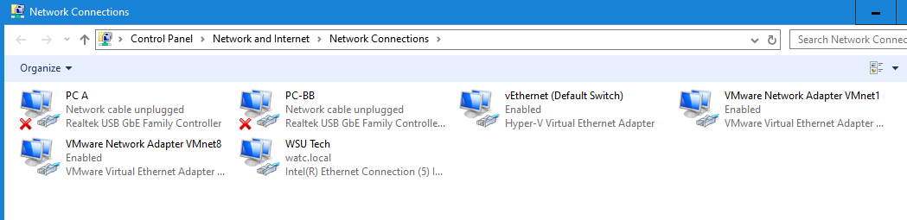
Wired NIC is the one labeled WSU Tech with the connection watc.local
SSID is watc.local
Speed is 100.0 Mbps
MAC address: 8C-EC-4B-78-CF-15
Multiple DNS addresses are listed likely due to redundancy and load balancing due to them being shared across a large network/group of hosts.
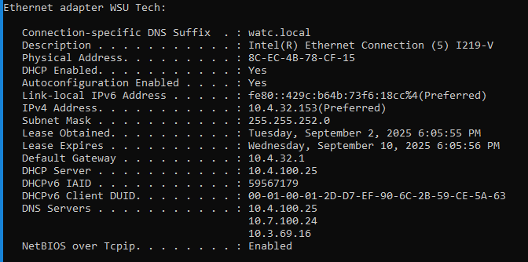
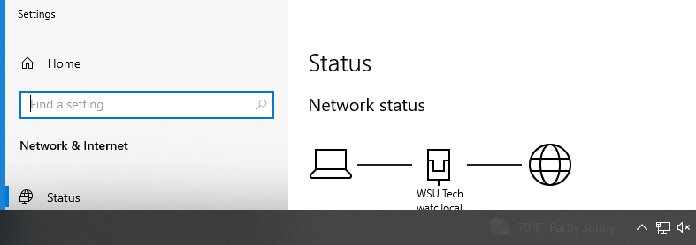

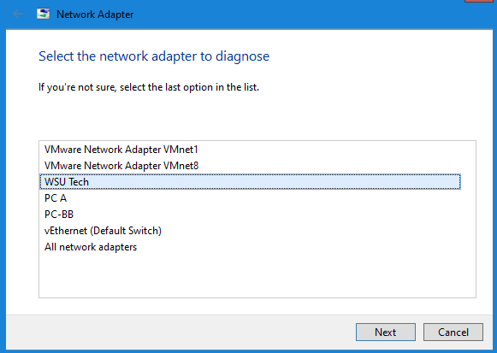
You would activate more than one NIC if you needed to be able to connect to more than network in the cases that you need to do that.

